Basic Statistics (Module – 4 (Part – 2))

**Name**: Nithin Dsouza

**Batch ID**: 05012021-10AM

1. For each of the following statements, indicate whether it is True/False. If false, explain why.



* 1. The sample size of the survey should at least be a fixed percentage of the population size in order to produce representative results.

Ans: TRUE, 10% of population is good maximum sample size as long as it does not exceed 1000.Sample must have a fixed percentage of population in order to produce representative result.

* 1. The sampling frame is a list of every item that appears in a survey sample, including those that did not respond to questions.

Ans: False, presence of non – responses increases error associated. Since avoiding non-responses in survey sample will lead to better results.

* 1. Larger surveys convey a more accurate impression of the population than smaller surveys.

Ans: True, as larger surveys convey involve in larger sample size which leads in reducing chances of errors.

1. *PC Magazine* asked all of its readers to participate in a survey of their satisfaction with different brands of electronics. In the 2004 survey, which was included in an issue of the magazine that year, more than 9000 readers rated the products on a scale from 1 to 10. The magazine reported that the average rating assigned by 225 readers to a Kodak compact digital camera was 7.5. For this product, identify the following:
2. The population

Ans: Total Magazine readers

1. The parameter of interest

Ans: Rating

1. The sampling frame

Ans: 9000

1. The sample size

Ans: 225

1. The sampling design

Ans: Z distribution

1. Any potential sources of bias or other problems with the survey or sample

Ans: Selection of the reader, selection of the issue which will contain the survey.

Q3) Suppose we want to estimate the average weight of an adult male in Mexico. We draw a random sample of 2,000 men from a population of 3,000,000 men and weigh them. We find that the average person in our sample weighs 200 pounds, and the standard deviation of the sample is 30 pounds. Calculate 94%,98%,96% confidence interval?

Q4) What are the chances that *X*  *?*

1. ¼
2. ½
3. ¾
4. 1

Ans: D Sample mean is always greater than population mean.

Q5) A book publisher monitors the size of shipments of its textbooks to university bookstores. For a sample of texts used at various schools, the 95% confidence interval for the size of the shipment was 250 ± 45 books. Which, if any, of the following interpretations of this interval are correct?

1. All shipments are between 205 and 295 books.
2. 95% of shipments are between 205 and 295 books.
3. The procedure that produced this interval generates ranges that hold the population mean for 95% of samples.
4. If we get another sample, then we can be 95% sure that the mean of this second sample is between 205 and 295.
5. We can be 95% confident that the range 160 to 340 holds the population mean.



Ans: D

Q6) Which is shorter: a 95% *z*-interval or a 95% *t*-interval for *μ* if we know that σ =s?

1. The z-interval is shorter
2. The t-interval is shorter
3. Both are equal
4. We cannot say

Ans: D, we cannot say that which is shorter because it is also depend on sample size.

Questions 8 and 9 are based on the following: To prepare a report on the economy, analysts need to estimate the percentage of businesses that plan to hire additional employees in the next 60 days.

Q7) How many randomly selected employers (minimum number) must we contact in order to guarantee a margin of error of no more than 4% (at 95% confidence)?

A. 600

B. 400

C. 550

D. 1000

Ans: A. 600

Q8) Suppose we want the above margin of error to be based on a 98% confidence level. What sample size (minimum) must we now use?

A. 1000

B. 757

C. 848

D. 543

Ans: C. 848

Q9) Examine the following normal Quantile plots carefully. Which of these plots indicates that the data?

1. Are nearly normal?

Ans: C

1. Have a bimodal distribution? (One way to recognize a bimodal shape is a “gap” in the

spacing of adjacent data values.)

Ans: D and B

1. Are skewed (i.e., not symmetric)?

Ans: B

1. Have outliers on both sides of the center?

Ans: A

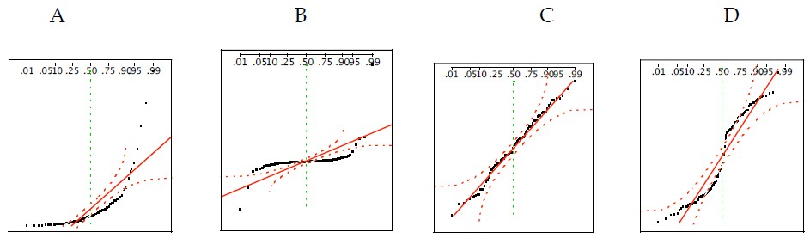

Q10) For each of the following statements, indicate whether it is True/False. If false, explain why.

The manager of a warehouse monitors the volume of shipments made by the delivery team. The automated tracking system tracks every package as it moves through the facility. A sample of 25 packages is selected and weighed every day. Based on current contracts with customers, the weights should have μ = 22 lbs. and σ = 5 lbs.

1. Before using a normal model for the sampling distribution of the average package weights, the manager must confirm that weights of individual packages are normally distributed.

Ans: True, In this case, at least 30 sample packages must be selected and weighed every day. Based on the central limit theorem, the sampling distribution of the sample mean approach normal distribution as the sample size become bigger (over 30).

1. The standard error of the daily average SE(𝑥̅) = 1

Ans: TRUE. Standard error equal to standard deviation divided by square root of sample size = 5/sqrt(25) =1.